|  |  |  |  |
| --- | --- | --- | --- |
| **Name of Student: NINAD AVINASH PATIL** | | | |
| **Roll No: 33** | | **Lab Practical Number: 1.1** | |
| **Title of Lab Practical: WAP in C# to determine the given date is magic or not using Console Application.** | | | |
| **DOP: 08/02/2021** | | **DOS: 15/02/2021** | |
| **CO Mapped: CO1** | **PO Mapped: PO3, PO5, PO7,**  **PO12, PSO1, PSO2** | **Faculty Signature:** | **Marks:** |

**Practical No 1.1**

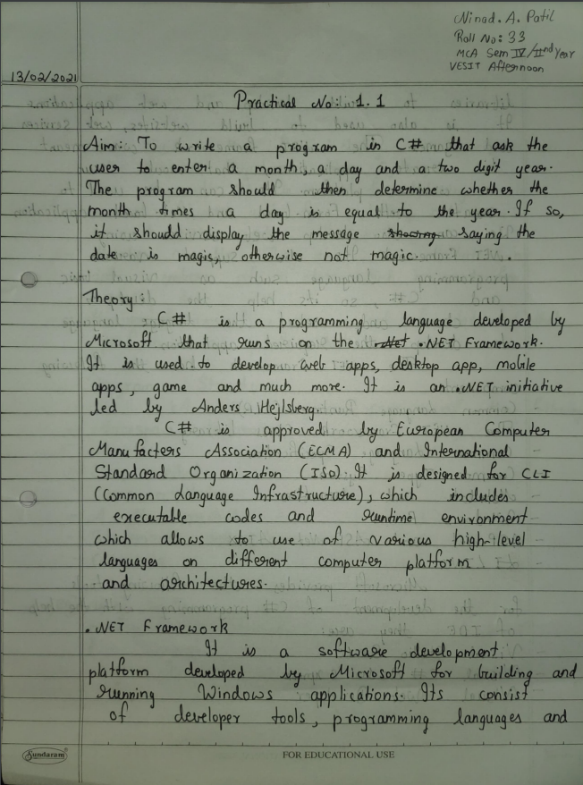

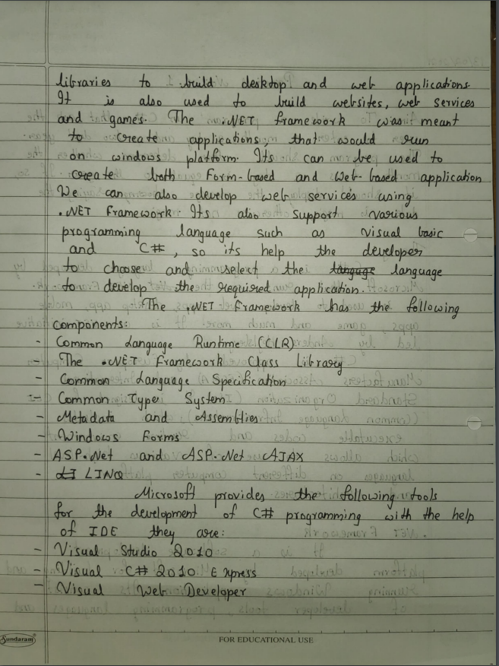

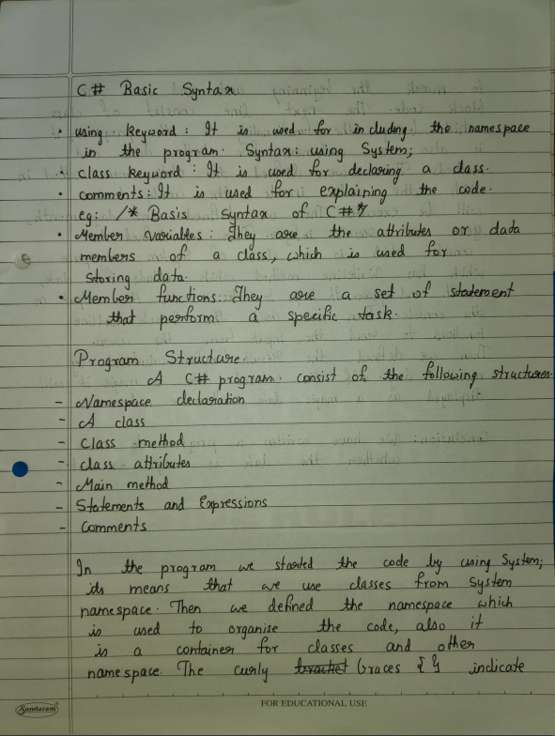

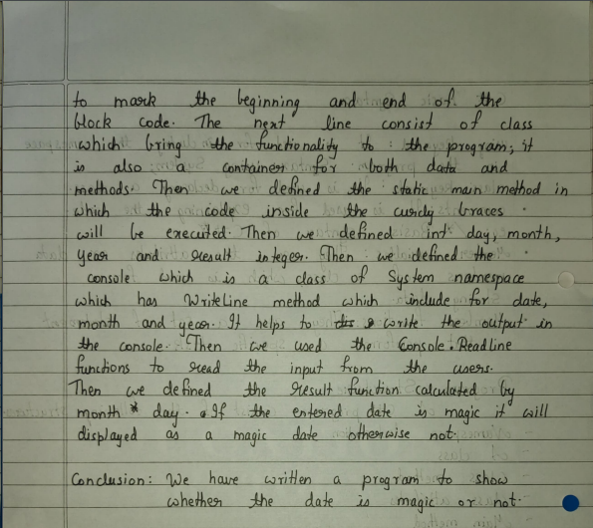

**Code:**

using System;

using System.Collections.Generic;

using System.Linq;

using System.Text;

namespace ConsoleApplication1

{

class Program

{

static void Main(string[] args)

{

int day, month, year, result;

Console.WriteLine("Enter Day:");

day = int.Parse(Console.ReadLine());

Console.WriteLine("Enter month:");

month = int.Parse(Console.ReadLine());

Console.WriteLine("Enter year:");

year = int.Parse(Console.ReadLine());

result = month * day;

if (result == year)

{

Console.WriteLine(day + "/" + month + "/" + year + " is a magic date");

}

else

{

Console.WriteLine(day + "/" + month + "/" + year + " is not a magic date");

}

Console.ReadLine();

}

}

}

**Output:**

